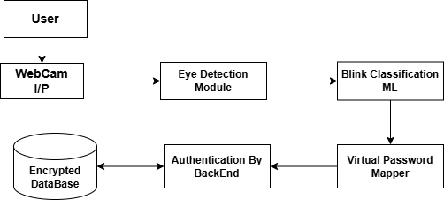
4.1.6 Architectural Design:

Fig - 1: Architectural Design

The system architecture is designed to enable secure, contactless authentication using eye-blink patterns through a layered processing approach.
- Input Layer (User & Webcam I/P): The user interacts with the system through a webcam, which continuously captures eye-related video frames in real time for authentication.
- Detection Layer (Eye Detection Module): The Eye Detection Module processes incoming frames to detect and track facial landmarks, focusing specifically on accurate eye localization.
- Classification Layer (Blink Classification ML): The Blink Classification ML module analyzes eye movements and classifies them into open, closed, or blink states, distinguishing intentional blinks from natural ones.
- Interaction Layer (Virtual Password Mapper): The Virtual Password Mapper converts the classified blink sequences into corresponding password inputs based on predefined mapping logic.
- Backend Security Layer (Authentication by Backend & Encrypted Database): The authentication backend encrypts the blink-pattern passwords, validates them against the encrypted database, and ensures secure verification.
- Output Layer (Access Decision): Based on verification results, the system either grants or denies user access, completing the authentication process securely.

Chapter – 6
DESIGN PHASE

6.1 Data Flow Diagram (DFD):
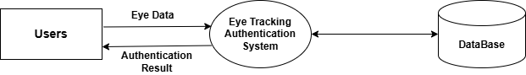
6.1.1 DFD Level – 0:
Fig - 2: DFD Level - 0

The above diagram represents the overall interaction between the user, the Eye Tracking Authentication System, and the database. In this diagram, the user provides eye-related input data to the authentication system through a webcam-enabled interface. The system processes this eye data to perform blink and gaze-based authentication by comparing it with securely stored templates in the database. After verification, the authentication system generates an authentication result, which is communicated back to the user. This diagram highlights the system as a single unified process, emphasizing its role in securely handling biometric eye data and validating user identity through encrypted database interactions.

6.1.2 DFD Level – 1:
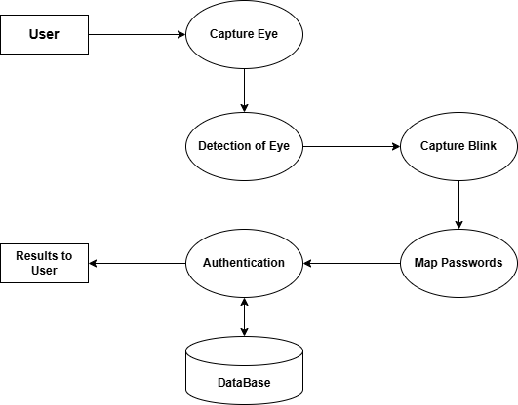

Fig - 3: DFD Level - 1
The above diagram provides a detailed breakdown of the internal processes involved in the Eye Tracking-Based Password Authentication system. The process begins when the user’s eye movements are captured using a webcam. The captured eye data is then forwarded to the eye detection module, where facial landmarks are analyzed to locate and track the eye region. Once the eyes are detected, the system captures intentional blink events and distinguishes them from natural blinks. These blink patterns are then mapped to corresponding password values using a virtual password interface. The authentication module verifies the generated password by comparing it with encrypted templates stored in the database. Based on the verification result, the system either grants or denies access and sends the authentication outcome back to the user. This diagram clearly illustrates the sequential flow of data, modular processing, and secure validation mechanism within the system.

6.2 ER (Entity Relation) Diagram:
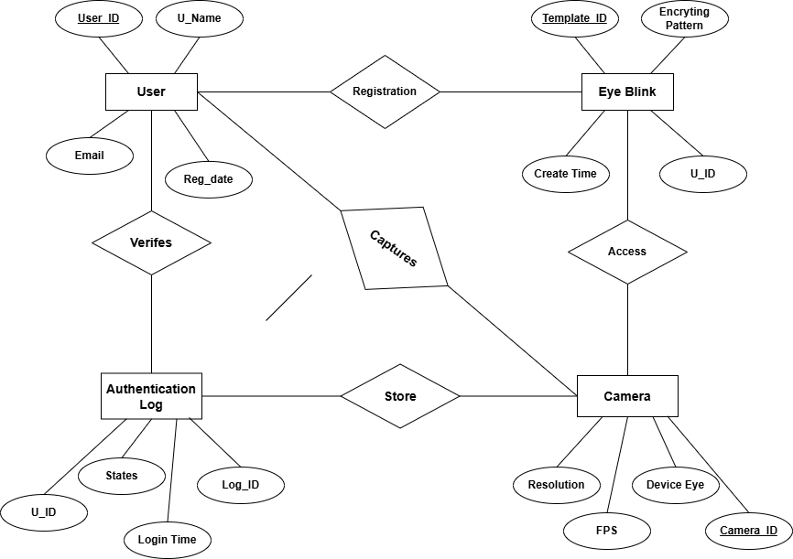

Fig - 4: ER Diagram
The above diagram represents the relationships among key entities such as User, Eye Blink, Camera, and Authentication Log. The User entity contains personal and registration-related information, while the Eye Blink entity stores encrypted blink-pattern templates associated with each user. The Camera entity is responsible for capturing live eye data during the authentication process, and the Authentication Log maintains records of login attempts with corresponding timestamps and status. This structure enables secure association of biometric data with user identity while ensuring traceability, accountability, and reliable auditing within the system.
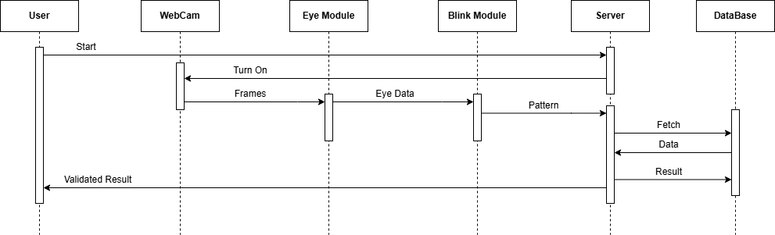
6.3 Sequence Diagram:
Fig - 5: Sequence Diagram

The above diagram explains the step-by-step interaction between system components during authentication. The process begins when the user initiates login, prompting the webcam to capture live video frames. These frames are processed by the eye module to extract eye data, which is then analyzed by the blink module to identify intentional blink patterns. The server receives the blink pattern, fetches stored templates from the database, and performs secure verification. Based on the comparison result, the server returns an authentication response to the user. This diagram highlights the real-time data flow and coordination between hardware, software modules, and backend services.

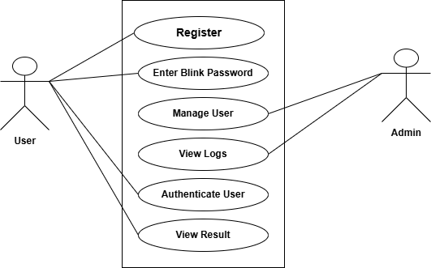
6.4 Use Case Diagram:

Fig - 6: Use Case Diagram
The diagram illustrates the functional interaction between users and the system. It identifies two primary actors: User and Admin. Users can register, enter blink-based passwords, authenticate themselves, and view results. Administrators manage user accounts, monitor authentication logs, and oversee system operations. This diagram provides a high-level view of system functionality and user responsibilities, ensuring clarity in role-based access and system usage.
6.5 State Diagram:
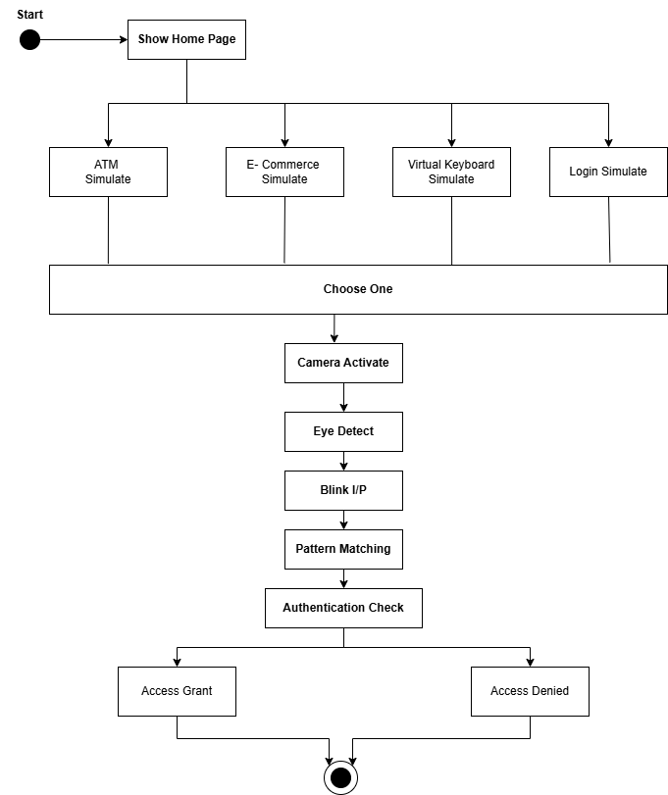

Fig - 7: State Diagram
The state diagram represents the internal workflow of the authentication process. The system starts by displaying the home page, after which the user selects an application mode such as ATM simulation, e-commerce, or virtual keyboard. Upon activation, the camera captures eye data, performs eye detection, accepts blink input, and matches the pattern against stored templates. Based on the authentication check, the system transitions to either Access Granted or Access Denied state. This diagram clearly models system behaviour and decision-making across different states.
6.6 Class Diagram:
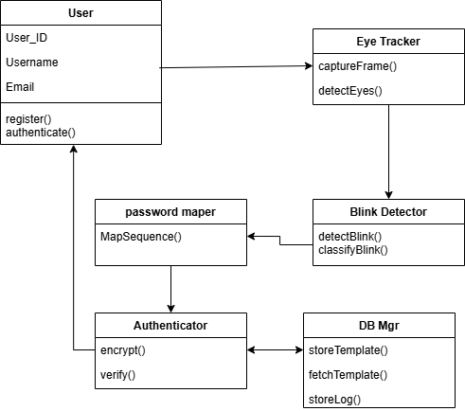
Fig - 8: Class Diagram
The diagram describes the object-oriented structure of the system. It consists of classes such as User, Eye Tracker, Blink Detector, Password Mapper, Authenticator, and Database Manager. Each class encapsulates specific responsibilities eye detection, blink classification, password mapping, encryption, verification, and data storage.
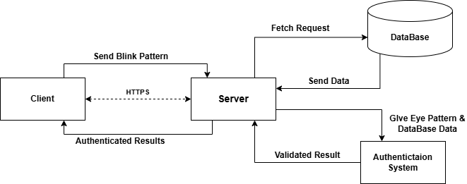
6.7 Client – Server Architecture Diagram:
Fig - 9: Client – Server Architecture Diagram

The client–server diagram illustrates the secure and structured communication architecture used in the Eye Tracking–Based Password Authentication system. In this model, the client represents the user-side application, where real-time eye tracking and blink pattern capture are performed using a webcam. Once the user enters a blink-based password, the captured blink sequence is preprocessed and securely transmitted to the server over an encrypted HTTPS channel, ensuring protection against interception, tampering, and man-in-the-middle attacks. On the server side, the authentication module receives the encrypted blink pattern and initiates validation by interacting with the central database. The server fetches the corresponding stored blink template, which is securely encrypted and stored during user registration. Advanced cryptographic techniques are applied to compare the incoming blink pattern with the stored template while maintaining data confidentiality. Based on the verification result, the authentication system determines whether the user is authorized or unauthorized. After successful validation, the server sends the authentication result back to the client, indicating either access approval or denial. All authentication attempts, including timestamps and status, are logged in the database for monitoring and audit purposes. This client–server architecture centralizes security controls, enhances scalability, and ensures consistent authentication logic across multiple clients. By combining encrypted communication, centralized verification, and secure data handling, the system achieves high reliability, strong security, and real-world deployability across enterprise, banking, healthcare, and IoT environments.

